The first part of the query creates a temporal table called “events” in which, for each user, returns the time that the event 4 and the next event are triggered. It is important to mention that this temporal table will return values from August 2019, the user 1 and event 4

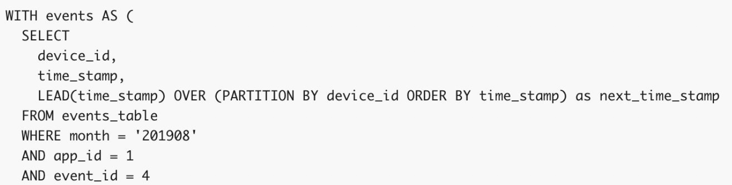

The second temporal table called “per_events” uses the previous created table and calculates the difference in seconds between one event and the next one. This means that it calculates for each device_id the time that it takes in seconds from one event to the next one.

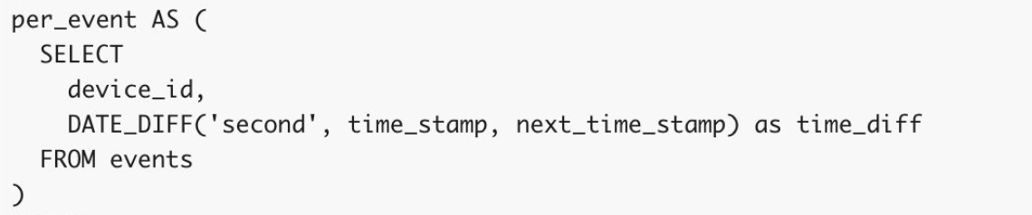

Finally, the last query uses the per_event table an calculates the average time that each user (device_id) takes to trigger the next event

